Ex. No. : 1 K MANOJ KIRAAN
240701305

Comparative Study of Low-Code Development

1. Aim
To conduct a comparative study of low-code application development using the Zoho Creator platform and traditional application development approaches by evaluating both methodologies in terms of development speed, cost, flexibility, scalability, security, maintenance, and overall suitability for different types of business applications.

2. Introduction

2.1 Low-Code Application Development

Low-code application development is a modern software development approach that enables the creation of applications with minimal hand-written code. Instead of relying entirely on traditional programming, low-code platforms provide visual development environments featuring drag-and-drop interfaces, pre-built templates, reusable components, workflow automation, and built-in database management. This approach significantly reduces development time while simplifying application design and deployment.

Zoho Creator is a leading low-code platform that allows both citizen developers and professional developers to rapidly build, customize, and deploy business applications. It offers intuitive form builders, report generation, workflow automation, role-based access control, API integrations, and the Deluge scripting language for implementing custom business logic. By minimizing the need for extensive coding

2.2 Traditional Application Development

Traditional application development follows the conventional Software Development Life Cycle (SDLC), where every component of an application—including the user interface, business logic, database design, and system integrations—is manually designed, coded, tested, and maintained using programming languages and frameworks such as Java, Python, C#, .NET, PHP, or JavaScript technologies.

This approach provides developers with complete control over application architecture, functionality, and performance, making it well suited for complex, highly customized, and enterprise-scale applications. However, traditional development generally requires skilled software developers, longer development cycles, higher development and maintenance costs, and extensive testing to ensure software quality, security, and reliability.

The emergence of low-code platforms has provided organizations with an alternative approach that emphasizes rapid application development and ease of use.

3. Objectives of the Study
The objectives of this study are:

- To understand the fundamental differences between the development lifecycles of low-code application development and traditional application development.
- To compare both approaches based on key parameters such as development speed, cost, skill requirements, flexibility, scalability, security, and maintenance.
- To evaluate the efficiency of the Zoho Creator low-code platform in developing business applications.
- To identify the types of business applications and use cases for which low-code and traditional development approaches are most suitable.
- To examine the advantages and limitations of adopting a low-code platform such as Zoho Creator compared with conventional software development methods.
- To provide recommendations that help organizations choose the most appropriate application development approach based on project complexity, available resources, and business requirements.

4. Development Lifecycle Comparison
- Traditional application development follows a sequential Software Development Life Cycle (SDLC), where each phase is completed separately before moving to the next.
- Low-code development using Zoho Creator integrates multiple development stages into a single visual platform, reducing overall complexity.
- The use of drag-and-drop tools, pre-built components, and workflow automation significantly reduces manual coding effort.
- Application development time is considerably shorter in the low-code approach compared to traditional development.
- Low-code platforms require less programming expertise, enabling both professional developers and citizen developers to build applications.
- Traditional development offers greater flexibility and customization, making it suitable for highly complex and enterprise-level applications.
- Low-code development reduces development and maintenance costs by minimizing coding, testing, and deployment efforts.
- Testing and deployment are faster in low-code platforms due to built-in tools and automated features.
- Traditional development provides greater control over application architecture, performance, and security but requires more time and skilled resources.
- Low-code platforms are well suited for business process automation, internal business applications, and rapid prototyping, whereas traditional development is better suited for largescale, highly customized software systems.

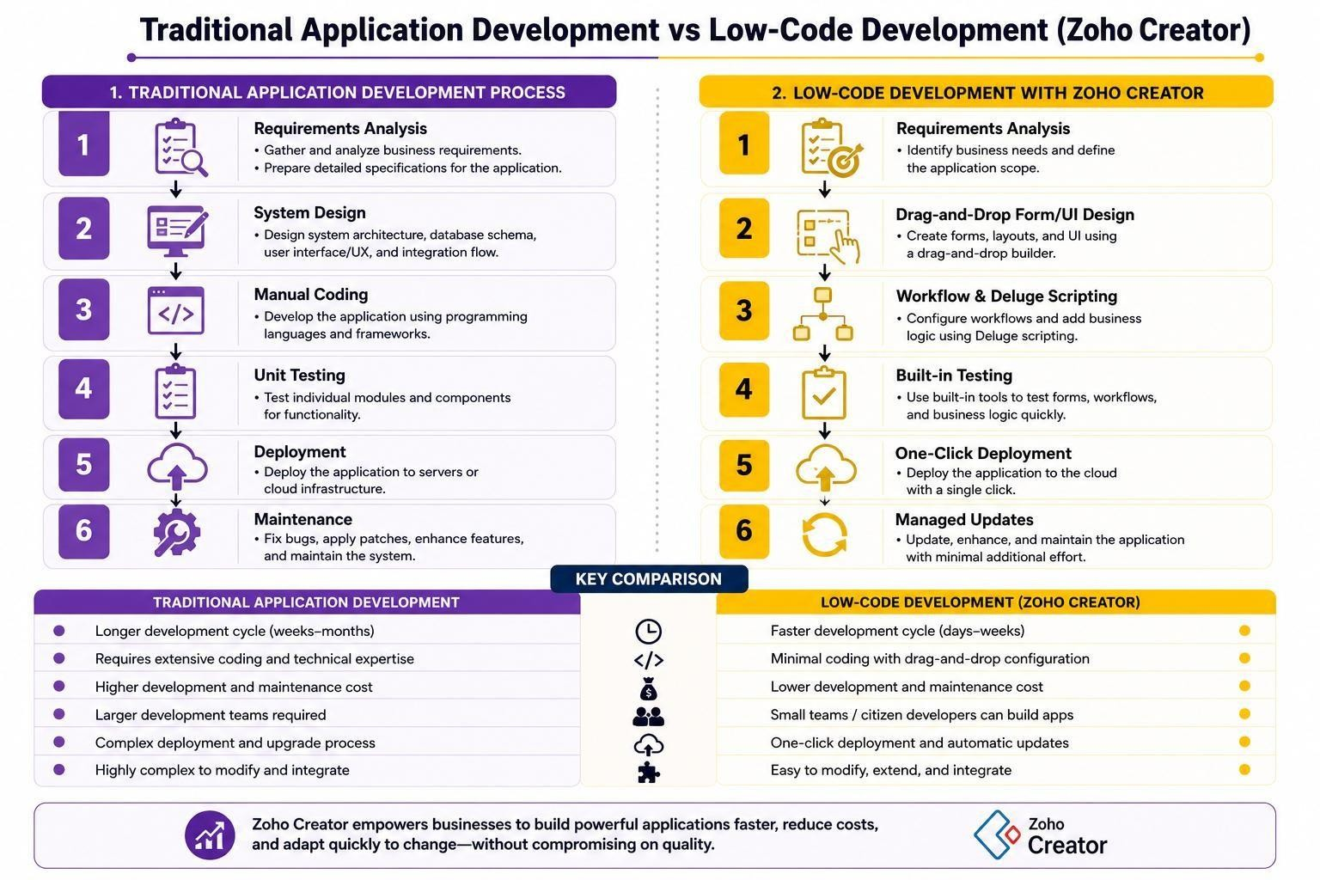
Low-Code Development (Zoho Creator) vs Traditional Application Development
Parameter Low-Code Development (Zoho  Creator) |  | Traditional Application  Development
Skill Requirement | Requires minimal coding knowledge. Basic Deluge scripting is sufficient for many applications. | Requires skilled software developers with knowledge of programming languages, frameworks, and system design.
Development Cost | Lower cost due to reduced coding effort, smaller teams, and platform-based infrastructure. | Higher cost due to larger development teams, longer development time, and infrastructure requirements.
Customization & Flexibility | Suitable for standard business applications. Complex custom requirements may be limited by the platform. | Highly flexible. Custom architecture, logic, features, and integrations can be developed from scratch.
Scalability | Suitable for departmental, small, and medium-sized applications. Large-scale scalability depends on platform capabilities. | Can be designed and optimized for large-scale, high-traffic, and distributed systems.
Maintenance & Updates | Zoho manages much of the infrastructure, security updates, and platform maintenance. | The development team is responsible for bug fixes, security patches, upgrades, and maintenance.
Integration Capability | Provides built-in connectors and APIs for integrating with thirdparty applications. | Provides complete control over integration but requires custom API development and testing.
Security & Governance | Includes built-in security features such as role-based access control and platform-level security. | Security must be designed and implemented manually at the application, database, and infrastructure levels.
Learning Curve | Easy to learn due to drag-anddrop tools and visual development. | Steeper learning curve requiring programming, frameworks, databases, and system design knowledge.
Deployment Time | Fast deployment using simple or one-click deployment processes. | Requires build pipelines, server configuration, testing, and deployment processes.
Vendor Lock-in | Application depends on the Zoho Creator platform and its ecosystem. | No major platform dependency; the organization owns and controls the source code and technology stack.
Ideal Use Case | Best suited for departmental workflow automation, internal tools, rapid prototypes, and smallto-medium business applications. | Best suited for mission-critical, highly complex, customized, and large-scale enterprise systems.
- Illustrative Example

Consider a healthcare organization that requires an internal Hospital Appointment Booking and Doctor Approval System.

6.1 Using Zoho Creator (Low-Code Development)

- Forms are created visually to collect patient details, doctor specialization, preferred appointment date, and time.
- A workflow automatically checks doctor availability and assigns the appointment.
- A simple Deluge script sends confirmation notifications to the patient and doctor.
- The system can be developed, tested, and deployed quickly using Zoho Creator's visual tools and built-in workflows.

6.2 Using Traditional Application Development

- Developers design database tables for patients, doctors, specializations, schedules, and appointments.
- Backend developers create APIs for patient registration, doctor availability, appointment booking, and cancellation.
- Frontend developers build separate interfaces for patients, doctors, and administrators using frameworks such as React or Angular.
- Additional backend logic is developed for appointment validation, scheduling conflicts, notifications, and access control.
- The application requires a longer development and testing process because each component must be manually designed, coded, integrated, and deployed.

- Advantages and Limitations
7.1 Low-Code Development — Advantages

- Faster application development and deployment.
- Reduces the need for large specialized development teams.
- Built-in security, hosting, and platform management.
- Easy to modify and maintain business applications.
7.2 Low-Code Development — Limitations

- May have limitations for highly specialized or performance-intensive applications.
- Creates dependency on the platform vendor and its ecosystem.
- May not be ideal for extremely large-scale or highly complex systems.

7.3 Traditional Development — Advantages

- Complete control over architecture, performance, and customization.
- Suitable for complex and mission-critical applications.
- Greater control over source code, infrastructure, and technology choices.

7.4 Traditional Development — Limitations

- Longer development and testing time.
- Requires specialized developers and larger budgets.
- Maintenance, upgrades, and security updates require continuous manual effort.

8. Result
The comparative study shows that low-code development using Zoho Creator is highly effective for rapidly developing standard business applications and workflow automation systems. It reduces development time, cost, and technical complexity.

However, traditional application development remains more suitable for highly customized, performance-critical, and large-scale enterprise systems where complete control over architecture and implementation is required.

9. Conclusion
This experiment demonstrates that low-code and traditional application development are complementary approaches rather than competing alternatives. Low-code platforms such as Zoho Creator are highly effective for departmental automation, internal business applications, workflow management, and rapid prototyping. They reduce development time and technical complexity through visual development tools, pre-built components, and automated workflows.

On the other hand, traditional application development remains essential for systems that require extensive customization, advanced performance optimization, complex architecture, large-scale scalability, and complete control over the technology stack.
Therefore, the choice between low-code and traditional development should depend on the complexity, scalability, customization, performance, budget, and technical requirements of the application. Understanding these trade-offs enables citizen developers and software engineers to select the most appropriate development approach for a specific business problem.

10. References
- Rosam, W. and Kalnichevski, O., Low-Code Development: A Practical Guide, BPB Publications.
- Zoho Creator Official Documentation
- Deluge Script Reference Guide
- Gartner Research, Magic Quadrant for Enterprise Low-Code Application Platforms.

